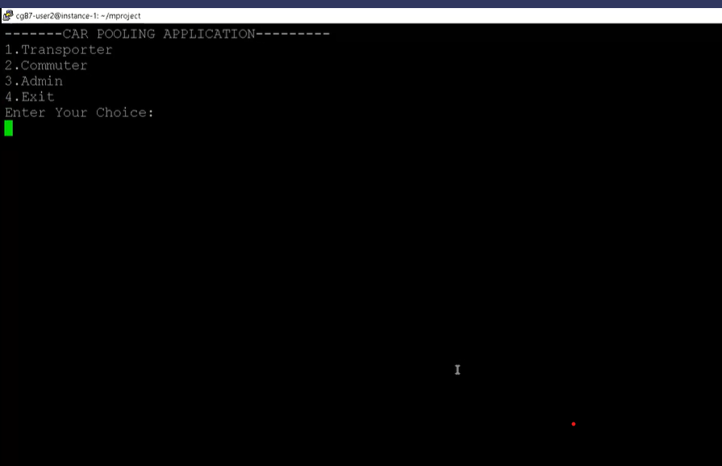

Main menu

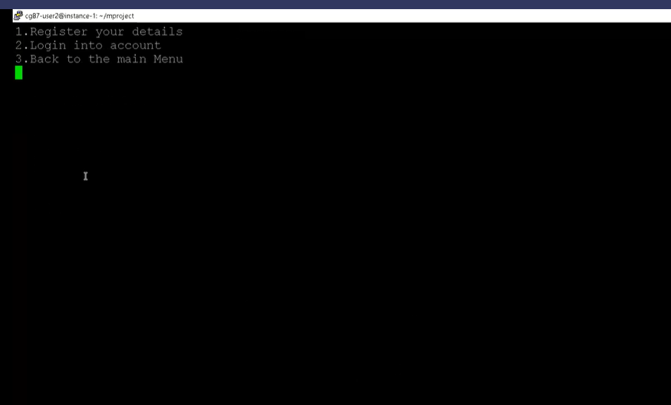

Transporter function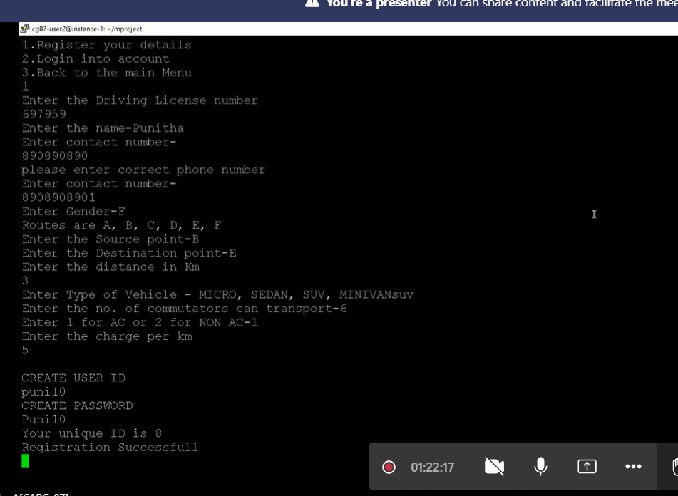

**UT_IT CASE 1**

Transporter registration process

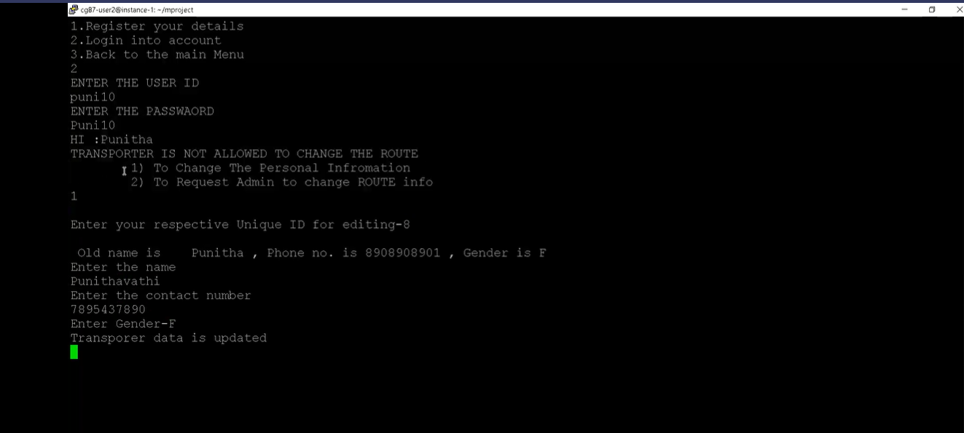

**UT_IT CASE 2**

Transporter modify details

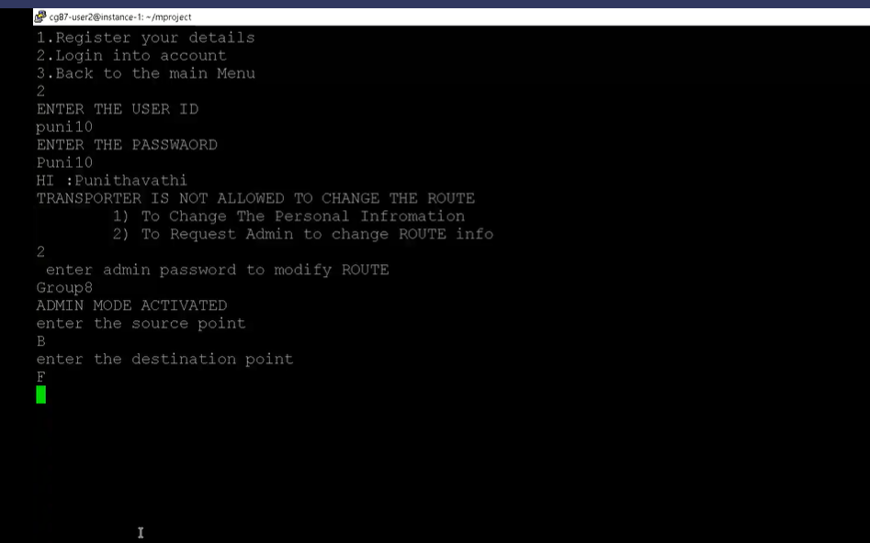

Transporter Route Info

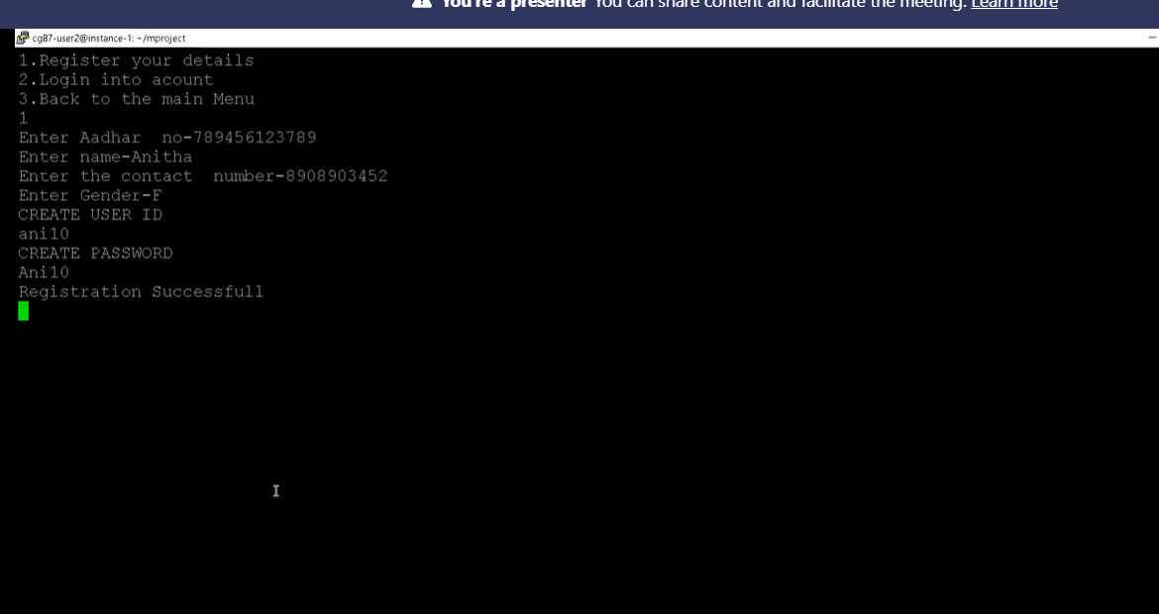

**UT_IT CASE 3**

Commuter Registration

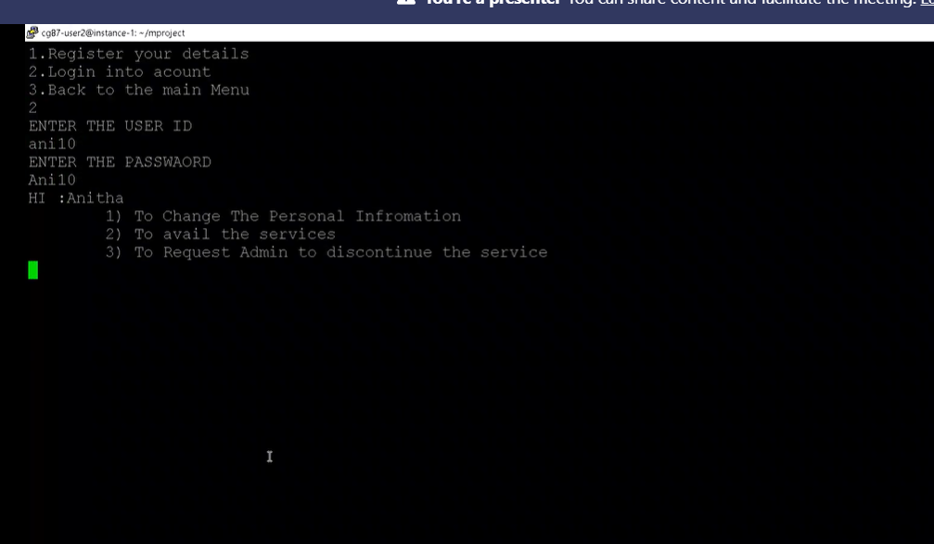

**IT CASE 4**

Commuter Login

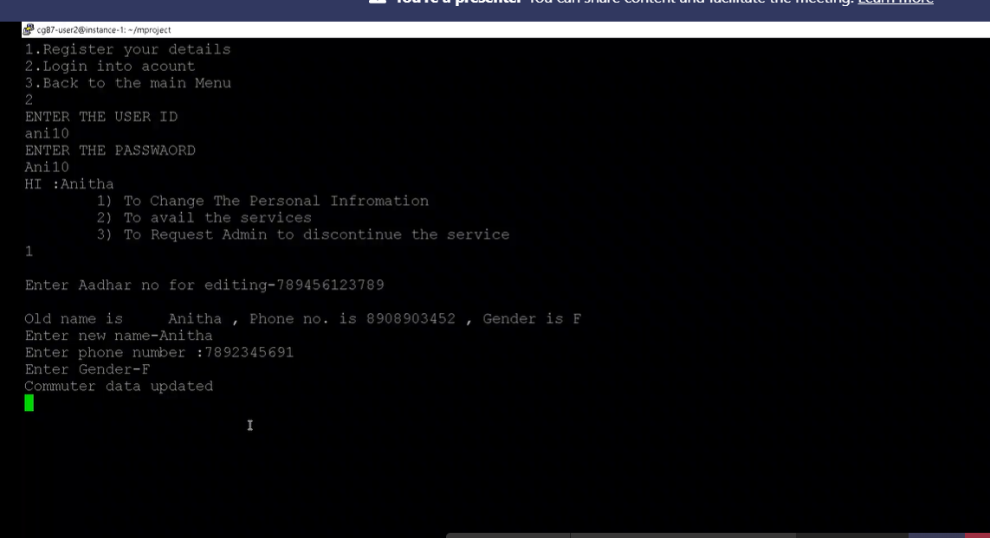

UT_IT Case 4

Modify personal details

UT_IT case4

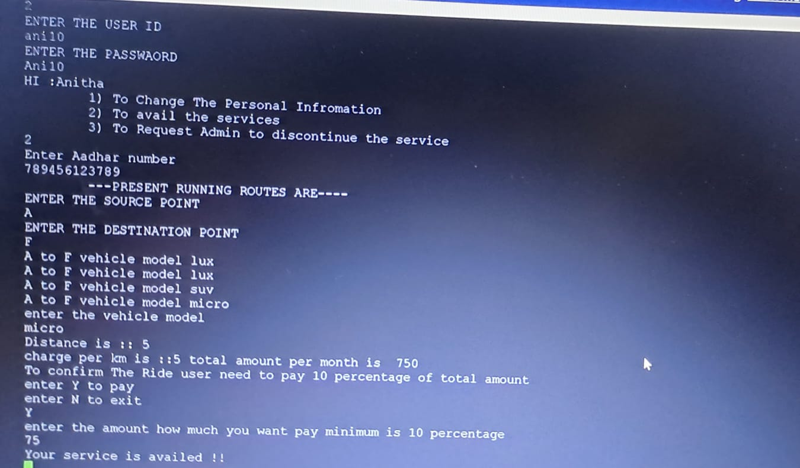

Avail services

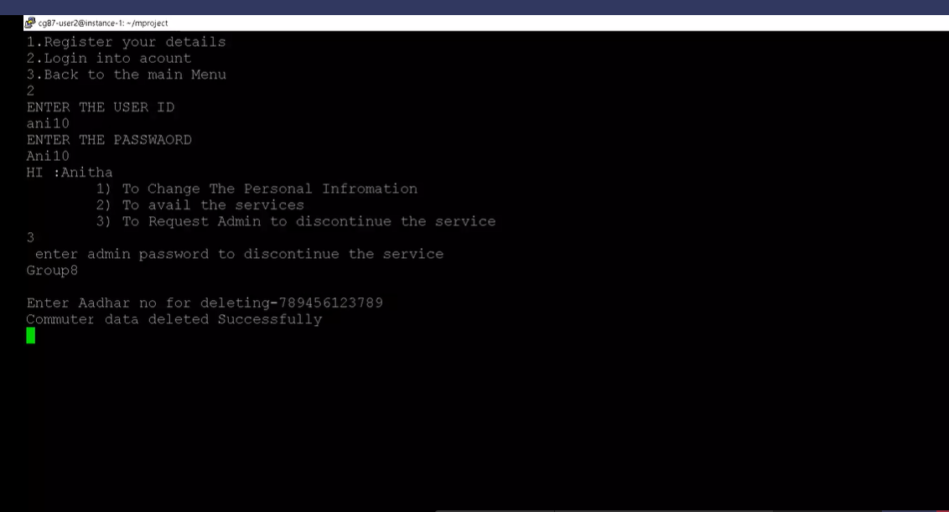

UT_IT Case 4

Commuter to discontinue the service

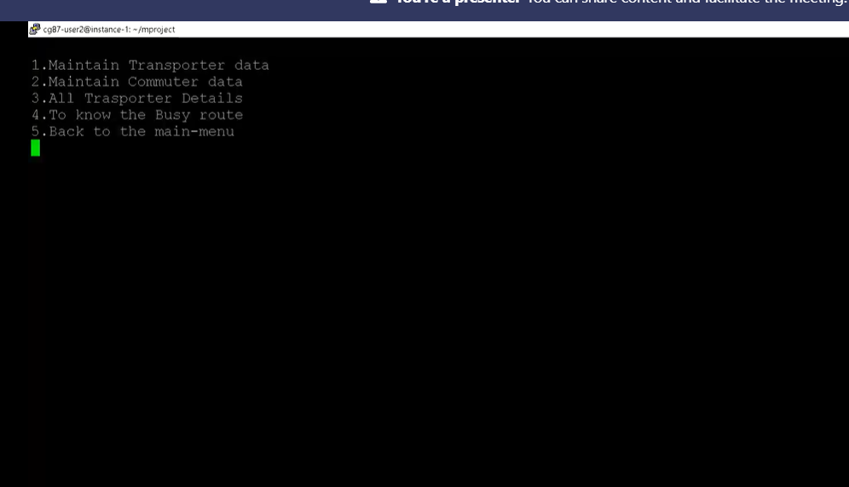

**IT CASE 5**

Admin Menu

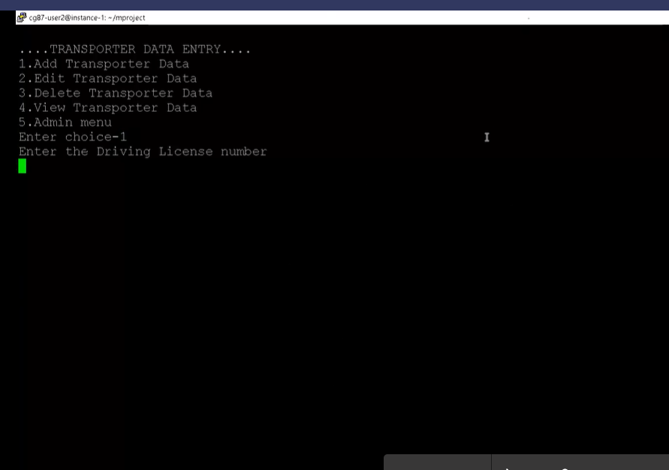

Admin side transporter submenu

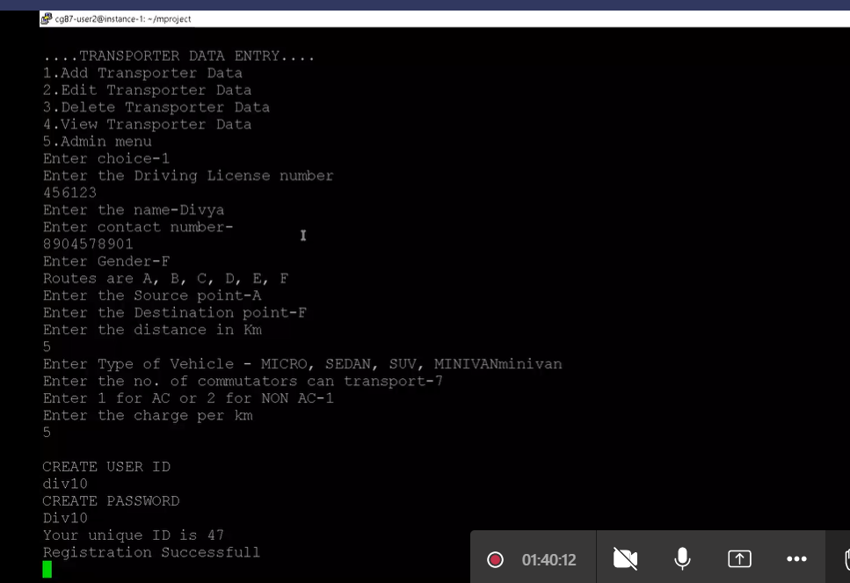

Transporter add details

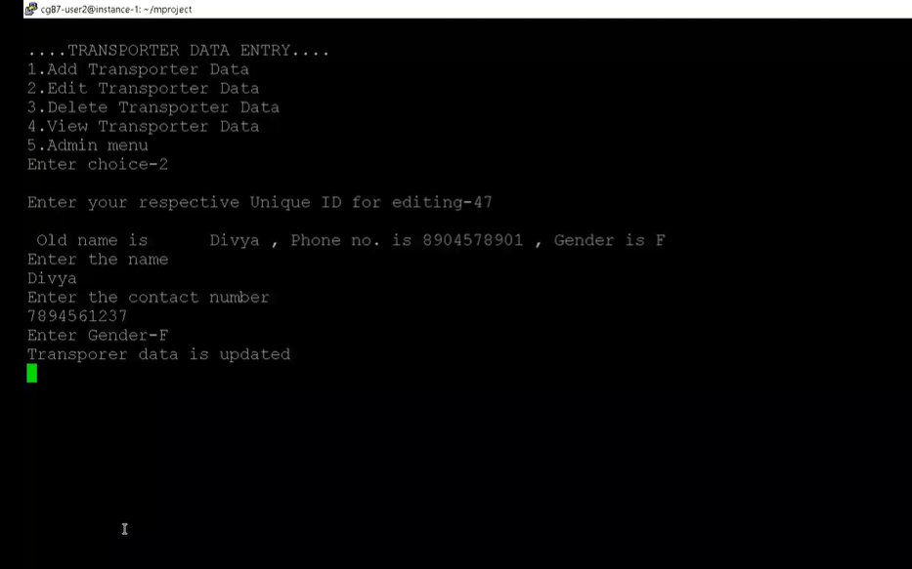

Transporter edit details

UT_IT Case 5

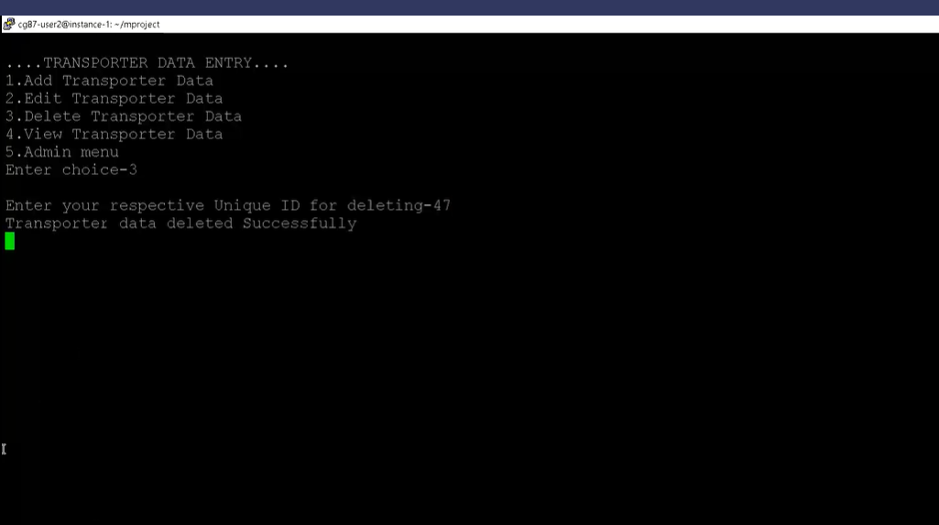

Transporter deletion

UT_IT Case 5

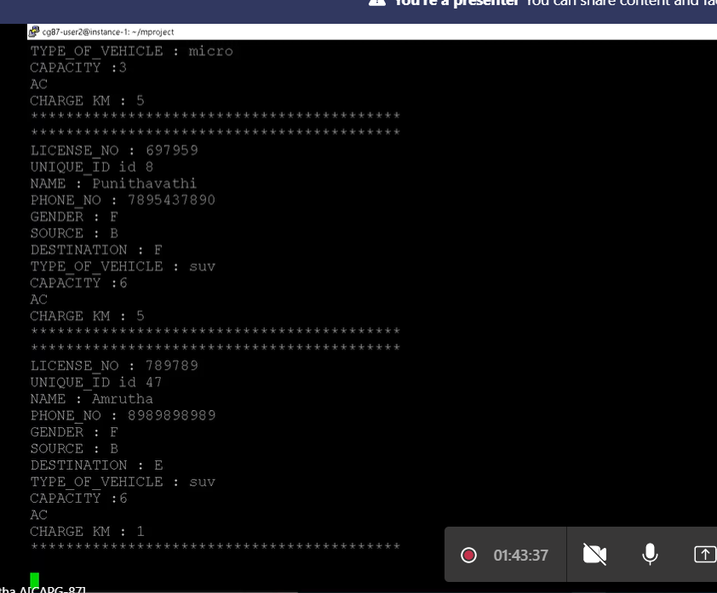

Transporter view

**IT CASE 6**

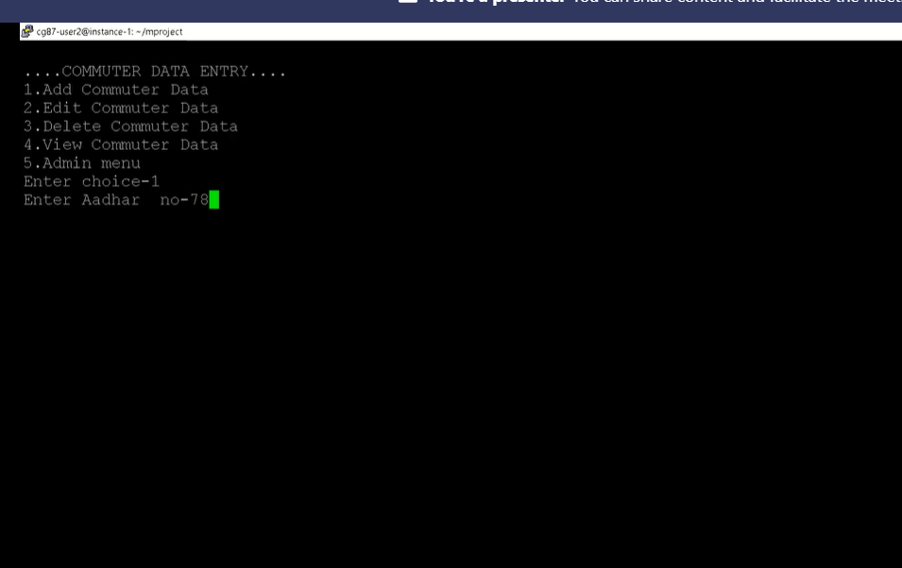

Admin side commuter submenu

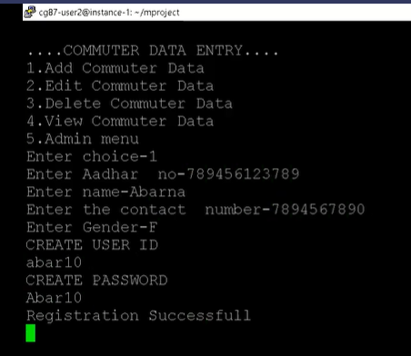

Commuter add data

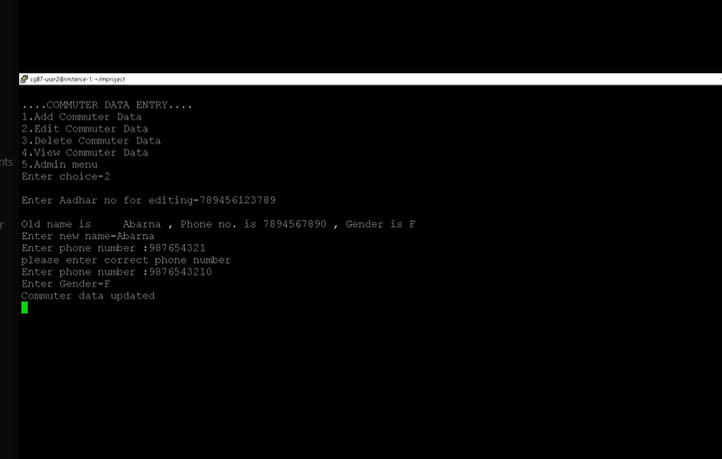

Commuter edit data

UT_IT Case 6

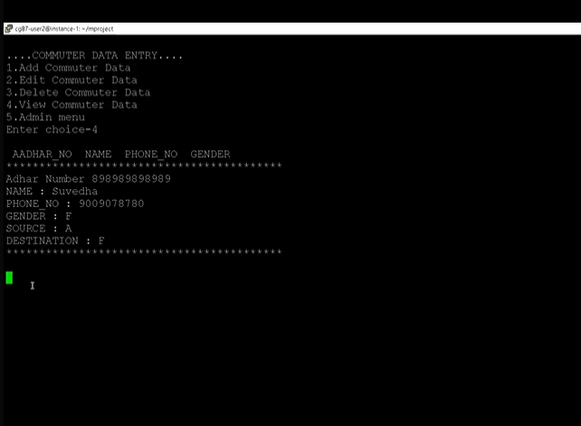

Commuter view data

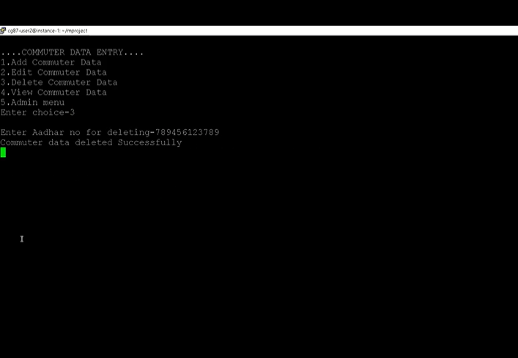

Commuter delete data

**UT_IT CASE 7**

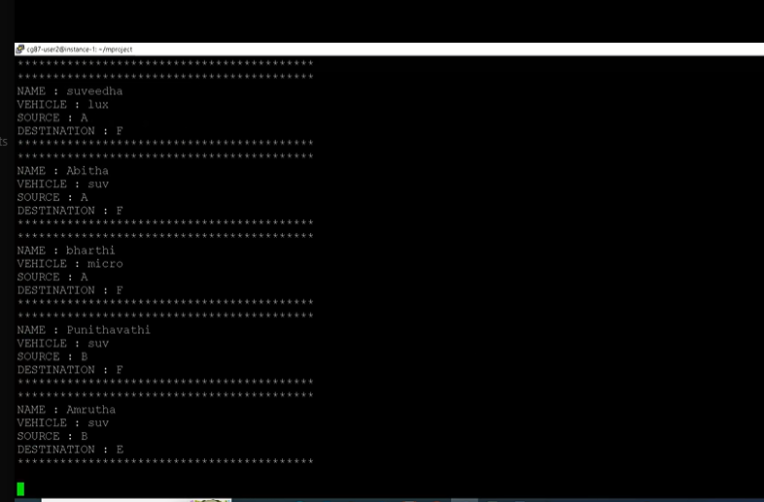

Report of all vehicles for all routes

**UT_IT CASE 8**

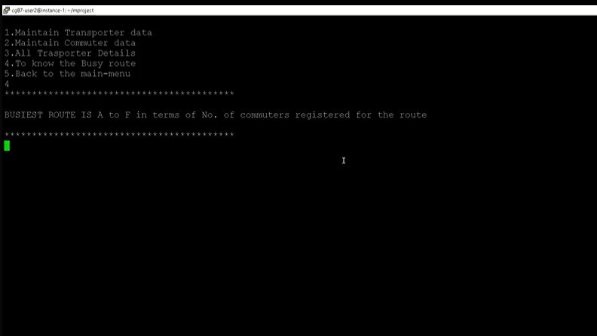

Report of Busiest route